Opiniano, Ezkylle 01/27/2026
NW – 301 6BLOCKTECH
Midterm Lab Activity 4: Hash Function using Keccak256
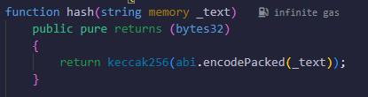
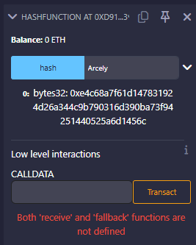

using abi.encodePacked
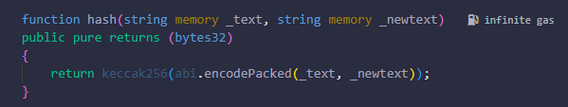
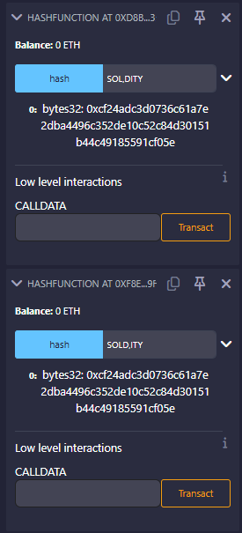
With abi.encodePacked
abi.encodePacked just concatenates the raw bytes of the strings.
So:
- "SOL", "DITY" → "SOLDITY"
- "SOLD", "ITY" → "SOLDITY"
Because the final byte sequence is the same, keccak256 hashes the same data → same bytes32 hash.
There is no information about where one string ends and the next begins.

using abi.encode
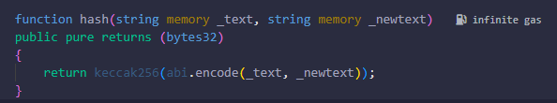
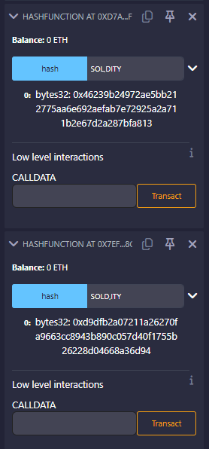
With abi.encode
abi.encode includes length and padding metadata for each argument.
So internally it becomes something like:
- "SOL"(3), "DITY"(4)
- "SOLD"(4), "ITY"(3)
Even though the visible text looks similar, the encoded bytes are structurally different, so the hash output is different.

Reflection:
- abi.encodePacked is efficient but can be unsafe with multiple dynamic inputs.
- abi.encode is slightly more expensive but provides stronger guarantees against collisions.
- For cryptographic hashing and security-sensitive logic, abi.encode is generally the safer choice.

